An Improved Heart Disease Prediction Using
Stacked Ensemble Method

Kanika Warman
Computer Science
California State University, East Bay
Hayward, CA
kwarman@horizon.csueastbay.edu

Abstract — This paper focuses on using the machine learning predictive algorithms to determine the heart disease. Heart disorder has just overtaken cancer as the world's biggest cause of mortality. Several cardiac failures, heart disease mortality, and diagnostic costs can all be reduced with early identification and treatment. Medical data is collected in large quantities by the healthcare industry, but it is not well mined. The discovery of previously unknown patterns and connections in this information can help with an improved decision when it comes to forecasting heart disorder risk. In the proposed study, we constructed an ML-based diagnostic system for heart illness forecasting, using a heart disorder dataset. We use data preprocessing techniques like outlier detection and removal, checking and removing missing entries, feature normalization, cross-validation, nine classification algorithms like RF, MLP, KNN, ETC, XGB, SVC, ADB, DT, and GBM, and eight classifier measuring performance metrics like ramification accuracy, precision, F1 score, specificity, ROC, sensitivity, log-loss, and Matthews' correlation coefficient, as well as eight classification performance evaluations. Our method can easily differentiate between people who have cardiac disease and those are normal. Along with the proposed methodology for the improvement in the prediction algorithm using stacking, an improvement and suggestion has been made to include feature engineering and multi-layer stacking that could help in better results.
Keywords — Machine Learning, Predictive Algorithm, Stacked Ensemble, Heart Disease

Introduction

Heart disease currently stands as a significant concern among various health conditions, leading to a substantial loss of lives. According to the World Health Organization (WHO), cardiovascular disease claims 17.7 million lives annually, comprising 31% of global deaths. The majority of these fatalities, approximately 85%, are attributed to heart attacks and strokes. With the rising prevalence of cardiac illnesses, the data surrounding the condition is becoming increasingly intricate, displaying nonlinearity, non-normality, and complex associations. Consequently, predicting heart disease poses a considerable challenge in medical data exploration, with clinicians facing difficulties in accurate prognostication. Numerous studies have attempted to employ advanced methodologies for analyzing heart disease data. However, inadequate representation of bagging in ensemble approaches can introduce excessive bias and lead to underfitting. Additionally, the real-time application of boosting is hindered by the growing complexity of the algorithm. In contrast, our proposed approach leverages the collective capabilities of multiple high-performing models in a classification or regression task, surpassing individual models in the ensemble while maintaining simplicity in construction. Despite the limited attention our suggested system has received, we have meticulously developed and tested it to yield promising outcomes and an improved prediction system.

LITERATURE OVERVIEW

The study aims to look into how data mining techniques may be used to diagnose cardiac problems. Practitioners and academics have previously employed pattern recognition and data mining technologies in the realm of diagnostics and healthcare for prediction purposes. A literature evaluation of cardiac disease predictions included a comparison of several methods:

Source | Datasets | FS | Attributes | Classifier & Validation techniques | Accuracy
Mohan S. [1] | Cleveland UCI repository | HRFLM | 14 attributes | DT, GLM, RF, and 5 more attributes. | 88.4%
Bashir S. | UCI dataset | Minimum Redundancy Maximum Relevance (MRMR) | FBS, Cp, Trestbps, Chol, Age, Slope, Sex, and more 7 attributes | NB, Logistic Regression, LR SVM, DT and RF | NB: 84.24% LR (SVM): 84.85%
Le, H.M. [5] | UCI Machine Learning Repository | Infinite Latent Feature Selection (ILFS) | 58 attributes | WEKE, NB, LR, Non-linear SVM (Gaussian, Polynomial, Sigmoid), and Linear SVM | Linear SVM: 89.93% , ILFS: 90.65%
Yadav D.C. and Pal [6] | Yadav D.C. and Pal [6] | Lasso Regularization, Recursive Features Elimination and Pearson Correlation | Resting, FBS, CP, Chol, Sex, Ca, Age, and 7 more attributes | Random Tree, M5P, and Reduced Error Pruning with Random Forest Ensemble Method | Random Forest ensemble method: 99%
Kabir P.B. and Akter S. [7] | Hungary (HU), Long Beach (LB), Cleveland (Cleve.), and Switzer | Hybrid | Cordocentesis, Max HR achieved, Epoch, Triglyceride, Sign, Coronary Infarction, Diastolic Pressure, and 6 more attributes | H-G-A with k-means | 94.06%
Islam M.T. [8] | UCI Machine Learning Repository | Hybrid | 14 attributes | LGBM , RF, NB, SVM, and 3 more algorithms | KNN: 100.00% DT: 100.00% RF: 100.00%
Patel J. [9] | Cleveland UCI repository | WEKA | 13 attributes | DT(J48), LMT, RF | J48 tree technique: 56.76%

methodology

This section proposes an advanced and efficient prediction of heart disease based on past historical training data. The ideal strategy is to analyze and test various data-mining algorithms and to implement the algorithm that gives out the highest accuracy. This research also consists of a visualization module in which the heart disease datasets are displayed in a diagrammatic representation using different data visualization techniques for user convenience and better understanding. The subsections that follow go through several materials and methodologies in detail.

3.1 Data Collection & Preprocessing

In this study, we used Statlog, Cleveland, and Hungary datasets which is a fact compilation of three datasets. There are 1190 records in all, with 11 characteristics and one target variable. Following are the attributes present in the dataset: Chest pain, cholesterol, sex, resting blood pressure, age, fasting blood sugar, max hate rate, exercise angina, old-peak, st slope, and target where 0 denoting no disease and 1 denoting illness.

For data pre-processing the following measures has been taken into consideration:
- Null values have been handled
- use the z-score to identify and eliminate outliers
- Convert the feature attributes to categorical
- Convert the dataset to numerical

3.2 Data Visualization and Analysis

After data has been cleaned and pre-processed, visualizations are performed on the dataset to see the patterns and trends in it. Several combinations and factors are taken into visualization that could yield results that could be helpful to understand the data more accurately. From the visualization, it could be identified how gender affects the heart activities and the know factors contributing to the target variable like Heart rate, max blood sugar and fasting sugar are not the only important factors.

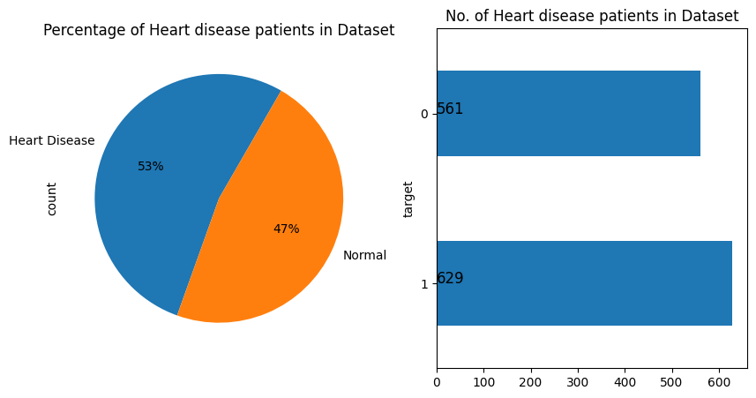

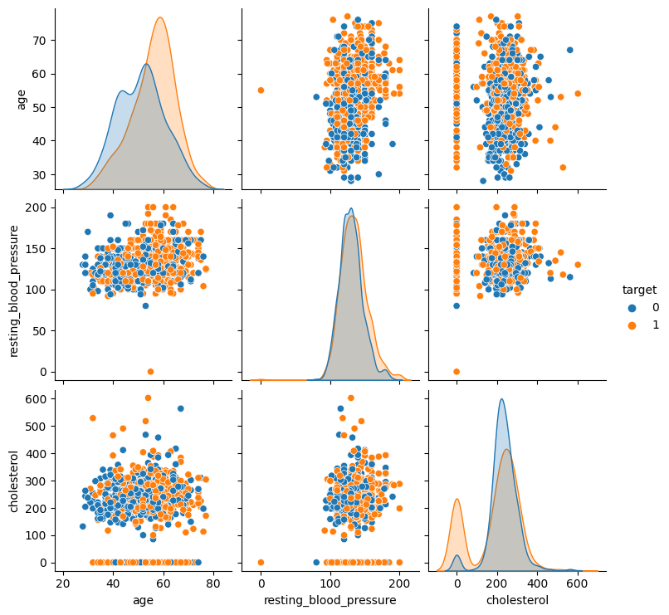

The attributes were normalized to view their results and compare them with others.

3.3 Feature Engineering

Feature engineering plays a pivotal role in enhancing the predictive power of models by transforming raw data into informative features. In the context of heart disease prediction, feature engineering could involve extracting relevant information from variables like cholesterol levels, blood pressure, and age, creating more meaningful input for the models. By carefully selecting, transforming, or combining features, one can highlight patterns that may be crucial for accurate predictions.

In our approach, we leverage feature engineering to extract valuable insights from diverse health indicators. We then employ a combination of four sophisticated models, each excelling in different aspects of heart disease prediction. This ensemble approach, comprising models such as decision trees, support vector machines, neural networks, and logistic regression, allows us to capitalize on the strengths of each model while mitigating individual weaknesses.

The decision trees excel in capturing nonlinear relationships, support vector machines provide robust classification boundaries, neural networks handle complex patterns, and logistic regression offers interpretability. By amalgamating these models strategically, we aim to create a comprehensive and robust prediction system that outperforms any single model in isolation. Through rigorous experimentation and evaluation in Section IV, we demonstrate the effectiveness of our combined approach in yielding superior predictive performance, showcasing the potential for enhanced accuracy and reliability in heart disease diagnosis.

  - Model Training

In this phase, machine learning classification methods are employed to distinguish between cardiac patients and healthy individuals. The system utilizes a variety of classification techniques, including RF Classifier, MLP, KNN, ET Classifier, XGBoost, SVC, AdaBoost Classifier, CART, and GBM. Rather than employing a standard stacked ensemble approach, our proposed system utilizes a two-layer stacking methodology. This involves constructing a base model and a meta-learner algorithm for the stacked ensemble.

Evaluation metrics such as sensitivity, specificity, precision, F1-Score, ROC, Log Loss, and the Mathew correlation coefficient are employed to assess the performance of each model. For instance, the RF Classifier utilizes information gain with "entropy" and "gini" for Gini impurity as its criteria for split correctness.

The MLP, or multi-layer perceptron, establishes multiple outputs from a set of inputs using a layered neural network. The K-NN method, although simple to implement, is susceptible to duplicated and unnecessary data. The Extra Tree Classifier constructs extremely randomized decision trees, and XGBoost handles both structured and tabular data efficiently.

The SVC method is common for classification and regression, aiming to find optimal paths for categorizing n-dimensional regions. AdaBoost Classifier employs adaptive boosting, reassigning weights based on instances' misclassifications. CART, a decision tree method, frequently divides data based on parameters, while GBM assembles a prediction system from weak frameworks, often decision trees.

In addition to these individual models, our unique approach involves a stacked ensemble strategy. Unlike bagging and boosting, stacking combines multiple prediction algorithms in a supervised manner, incorporating a meta-learner to optimize the combination of basic learners. This multi-layer stacking, presented in the subsequent sections, strives to bring together diverse and strong groups of learners for superior predictive performance.
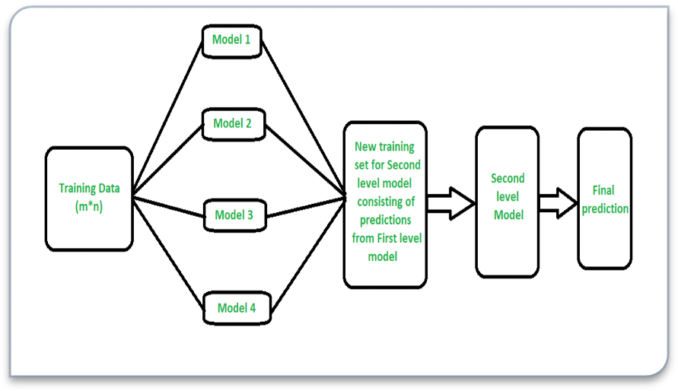

Import all of the necessary libraries.

After loading our dataset, we clean and preprocess it.

We use the z-score to identify and eliminate outliers.

We divided the data into two parts: training and testing, with 80/20 percentages.

We developed a model using cross-validation.

Use feature selection to identify key attributes and remove the remaining from the dataset.

For a stacked ensemble technique, we stack all of the models such as RF, MLP, KNN, ETC, XGB, SVC, ADB, CART, and GBM and evaluate their performances.

Choose only the top performing models for stacking.

Perform 2-level stacking using selected base models and meta training.

Assess and compare the model to previous models.

results and comparison

This section presents the outcomes of changing the ten orders indicated above. PRC, Sensitivity, Specificity, F1 Score, ROC, Log Loss, and MCC are the most common evaluation metrics used in this analysis. Complexity refers to a calculation that defines the importance of a segment of the review, whereas recall refers to the number of times genuinely qualified people are recovered.

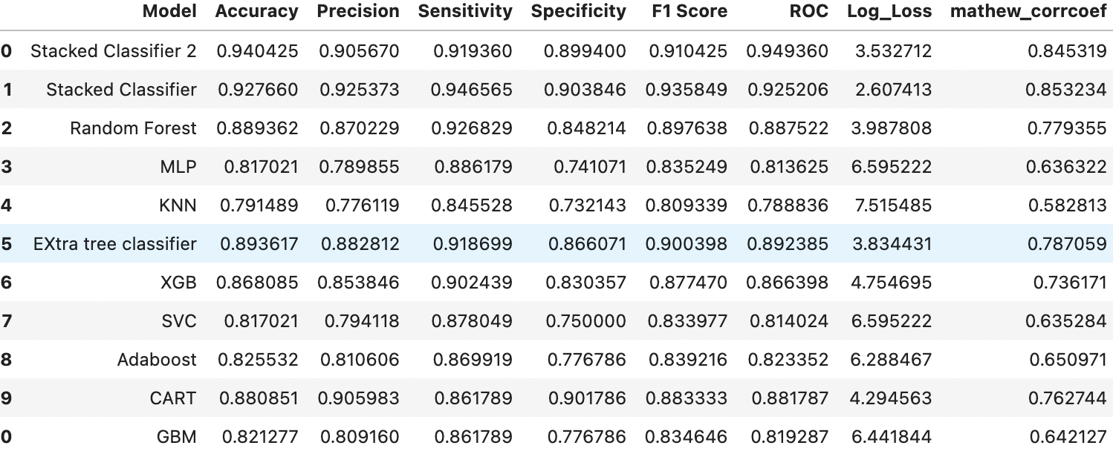

The Stacked Ensemble Classifier, with an accuracy of 0.940, sensitivity of 0.934, specificity of 0.893, best f1-score of 0.916, minimum Log Loss of 3.08, and highest ROC value of 0.909, is the best performer. Of the same evaluation metrics in every region, Random Forest has the highest sensitivity level, while Extra tree classifier is second best.

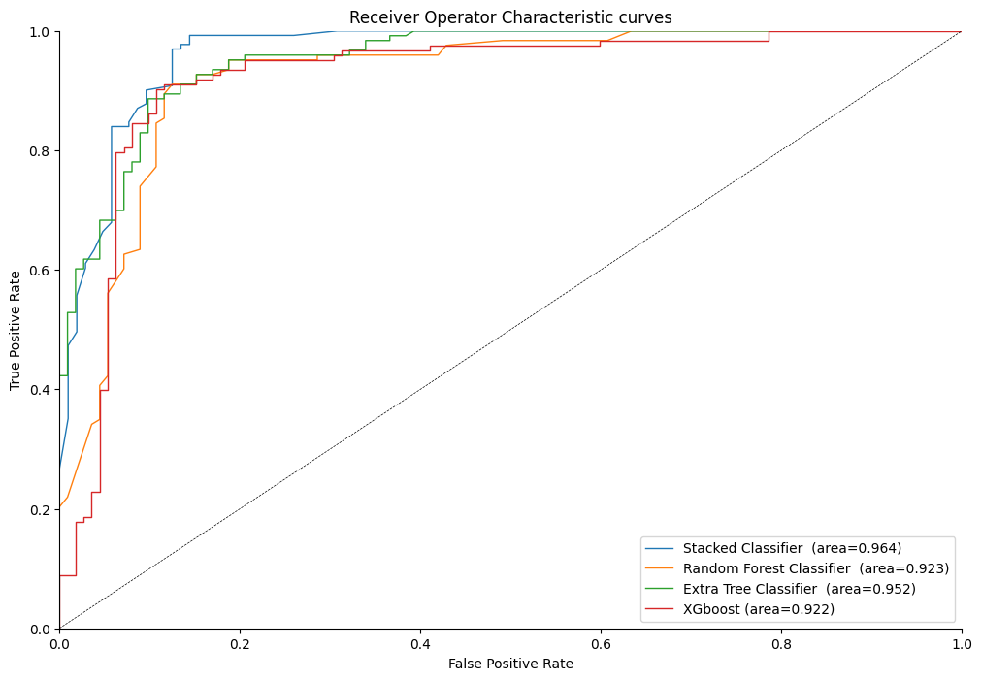

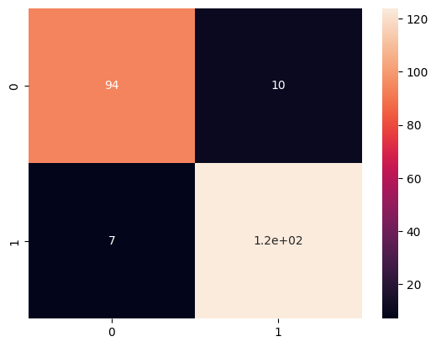

Conclusion

Predicting cardiac illness has become a major concern and priority in the medical industry. Using the Stacked Ensemble Classifier, we have shown an improved heart disease prediction method. It incorporates a number of different prediction techniques. In this work, we examined the significance of prediction performance, precision, ROC sensitivity, Specificity, F1 Score, Log Loss, and MCC. To identify whether or not a person has a heart problem, we applied machine learning techniques. As a consequence of the findings, we discovered that the enhanced stacked ensemble approach provides better accuracy than previous methods. For future research possibilities, we will aim to train and test on a large medical data set using many ensemble methods to see if we can enhance their performance. Our ensemble method is superior to traditional methods, as even if it is overfitting at times, it usually reduces variances, as well as minimizes modeling method bias. It also has superior Predictive performance, reduces dispersion and our approach has superior efficiency by choosing the best combination of models.
Feature selection is crucial for enhancing model efficiency and interpretability by identifying relevant variables.
When combined with multi-layered stacking, it further refines the model's predictive power. By selecting the most informative features, the stacking ensemble can focus on key patterns and relationships, potentially improving generalization to new data.
Feature selection helps in eliminating noise and redundancy, enhancing the ensemble's ability to capture complex relationships. Multi-layered stacking leverages diverse base models, mitigating biases and producing more robust predictions. This combined approach contributes to higher accuracy, precision, and overall model effectiveness.
While stacking is a powerful technique, caution is needed to avoid overfitting, especially when using multiple layers of models. It's essential to strike a balance between model complexity and generalization.
Additionally, stacking may be computationally intensive, requiring careful consideration of resource constraints.
Interpretability may also be a challenge as the ensemble becomes more complex.
Practitioners should validate results rigorously and be mindful of the potential for increased model complexity leading to diminished interpretability and longer training times.

References

- Md. Maidul Islam 1, Tanzina Nasrin Tania1, Sharmin Akter1, and Kazi Hassan Shakib2 paper on “An Improved Heart Disease Prediction Using Stacked Ensemble Method” in arxiv, in Machine learning
- Palaniappan, S. and Awang, R., 2008, March. Intelligent heart disease prediction system using data mining techniques. In 2008 IEEE/ACS international conference on computer systems and applications (pp. 108-115). IEEE.
- 3. Ramalingam, V.V., Dandapath, A. and Raja, M.K., 2018. Heart disease prediction using machine learning techniques: a survey. International Journal of Engineering & Technology, 7(2.8), pp.684-687.
- 4. Bashir, S., Khan, Z.S., Khan, F.H., Anjum, A. and Bashir, K., 2019, January. Improving heart disease prediction using feature selection approaches. In 2019 16th international bhurban conference on applied sciences and technology (IBCAST) (pp. 619-623). IEEE.
- 5. Le, H.M., Tran, T.D. and Van Tran, L.A.N.G., 2018. Automatic heart disease prediction using feature selection and data mining technique. Journal of Computer Science and Cybernetics, 34(1), pp.33-48.
- 6. Yadav, D.C. and Pal, S.A.U.R.A.B.H., 2020. Prediction of heart disease using feature selection and random forest ensemble method. International Journal of Pharmaceutical Research, 12(4), pp.56-66.
- 7. Kabir, P.B. and Akter, S., 2021, September. Emphasised Research on Heart Disease Divination Applying Tree Based Algorithms and Feature Selection. In 2021 International Conference on Innovative Computing, Intelligent Communication and Smart Electrical Systems (ICSES) (pp. 1-6). IEEE.
- Islam, M.T., Rafa, S.R. and Kibria, M.G., 2020, December. Early Prediction of Heart Disease Using PCA and Hybrid Genetic Algorithm with k-Means. In 2020 23rd International Conference on Computer and Information Technology (ICCIT) (pp. 1-6). IEEE.
- Patel, J., TejalUpadhyay, D. and Patel, S., 2015. Heart disease prediction using machine learning and data mining technique. Heart Disease, 7(1), pp.129-137.

